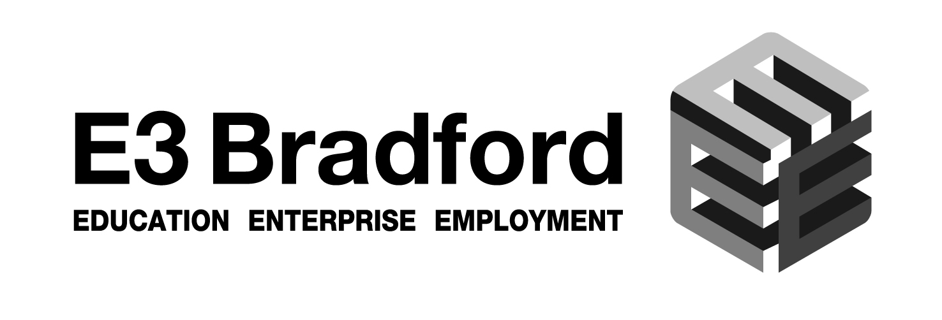 | 
LEEDS CITY REGION CITY DEAL APPRENTICESHIP HUB PROGRAMME
BUSINESS ENGAGEMENT FORM

By signing this statement I confirm that:

- This organisation intends to offer Apprenticeship/s opportunities in the near future;
- That this organisation has not had an Apprenticeship start within the organisation in the last 12 months.

Name of Business
Nature of Business/sector

Contact details of business | Address:  Tel:  Email:
Number of employees

Name & position of person making commitment | Name (print):  Position:
Signature from Business
Date commitment/intention made

To receive more details please scan this form to Rachel Fuller at Bradford Chamber of Commerce
Rachel.fuller@wnychamber.co.uk Or telephone Rachel on 01274 206656.

